Remote Learning Behaviour
This document works alongside our school Acceptable User and
E-Safety Policy. These can be found in your Homework Planner or on our school website.

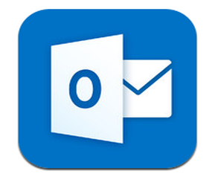
Treat your learning online the same as your classroom learning in school. The same high expectations stand, and our rules apply in respect of behaviour and conduct.

When you use any online learning tools you should always think that you are in a classroom. So, whenever you enter a Team area, think of it as entering into a virtual classroom. Always maintain disciplined and respectful classroom conduct and try to remember that you are in a learning environment and not a social setting.

Always use classroom language whenever speaking or writing.

You can use the Team chat feature to make relevant comments or ask questions. Comments should be regarding the work only, and you should read the previous comments before asking a question. If you don’t want to ask question in front of your peers, then email your teacher.

Always remember to be respectful and polite towards staff and fellow students.

Never share passwords or other sensitive information.

If you ever experience online abuse, please report this to your class teacher.

You have your own social media platforms for communicating with friends, for reasons not associated to school.
USE THESE and NOT school provided facilities to do this.

