Help guide 1: How to access Microsoft 365 via the School website and then on to Teams and Outlook
https://www.st-maryshigh.lancs.sch.uk/curriculum1/bsm-at-home/
On the school website, on the main home page, click in the top right hand corner where it says Office 365.
This link takes you to your email account link, one drive where you can store documents and the Teams link.

Once you have clicked on the Office 365 link it will take to a window which asks for your email address. THIS IS YOUR SCHOOL EMAIL ADDRESS. (A pupils email address is usually the year they started at Brownedge for example if they started in 2017, then it will be 17, followed by their surname and then the initial for their first name. For example 03maultt@st-maryshigh.lancs.sch.uk) It will then ask you for your password. THIS IS YOUR SCHOOL EMAIL ADDRESS PASSWORD.
The pupils password is set by them and so is private.
If pupils do not know their account or password details then they will need to contact school or email ictrequest@st-maryshigh.lancs.sch.uk to find out what it is or get it reset.

Once a pupil has logged on then this screen appears. If they need their email then they click on Outlook and if they want to go onto Teams they click Teams.

Once a pupil has clicked on Teams a screen similar to this will appear. The Teams for each pupil will be their classes and then any other Teams they are part of for example Chaplaincy and form groups.
This pupil is in Year 9 and so has lessons in RE, Maths, French, History, PE, Science and Music.
The lessons being set by teachers will now be within the Teams for that class/subject.

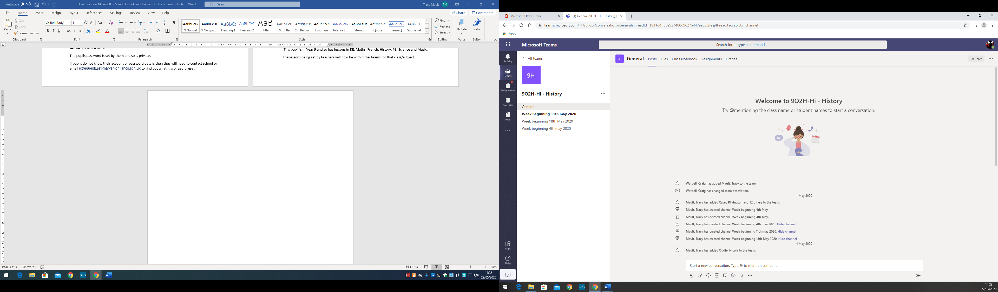
A channel
If a pupil clicks on a Team this screen will appear. I have clicked on the History Team. This is the Team for this pupils History Class.
The General Screen is the main page for the Team. On the left hand side there will be ‘channels’ of areas entitled ‘week beginning…’. These channels are where pupils work will be uploaded by the teacher. Within the channels there will be posts by the teacher, as seen below. However if the pupil clicks on files then any documents the teacher has provided for the lessons will be there.

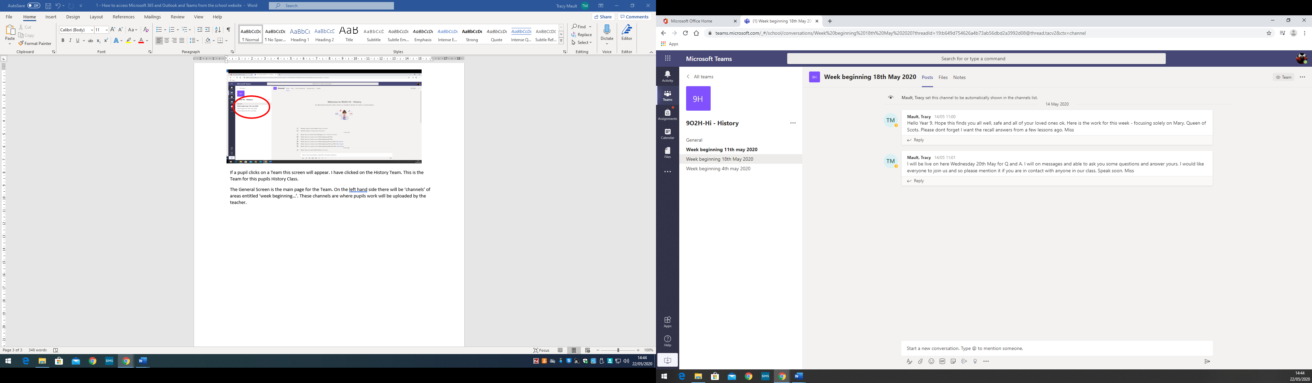

For every lesson pupils are expected to submit a piece of work. This could be through answering questions on a Quiz, uploading a photo or a new word document or completing a worksheet.
All of these tasks will be set through and completed on the assignment function on the General page.
Teachers will be setting tasks or quizzes on the assignment page. PUPILS ARE EXPECTED TO RETURN THESE BY 8AM THE DAY AFTER THEY HAVE BEEN SET (please see the new timetable for Year 7-9 from 1st June included in this pack). Please see help guide 2 for how pupils upload and submit work.

This work will receive some form of feedback from the teacher. This could be a score, a comment, a praise icon or a summary of what pupils have done well and need to improve upon. This feedback will be returned to pupils and again can be found in the assignment link. It can also be seen in the grades link, where all of the pupils feedback is stored in one place.

